Homework #4

Xavier Cho

Computer Graphics – CSCE A385

Dr. George Kamberov

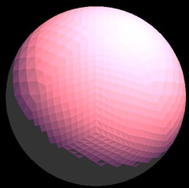

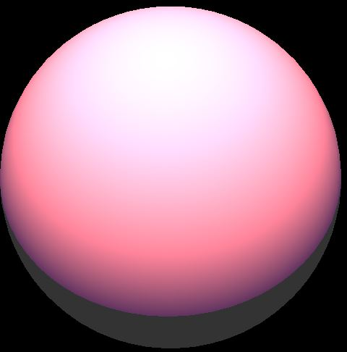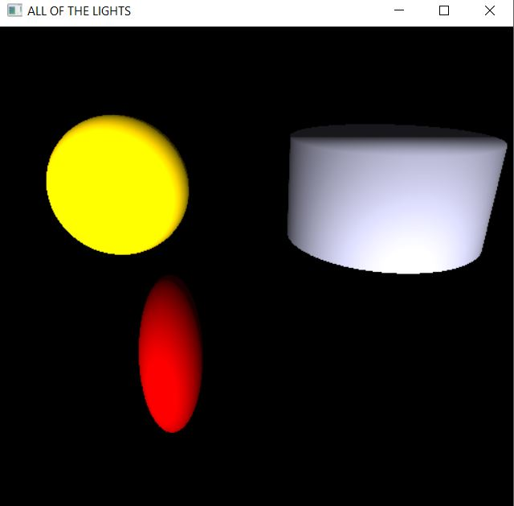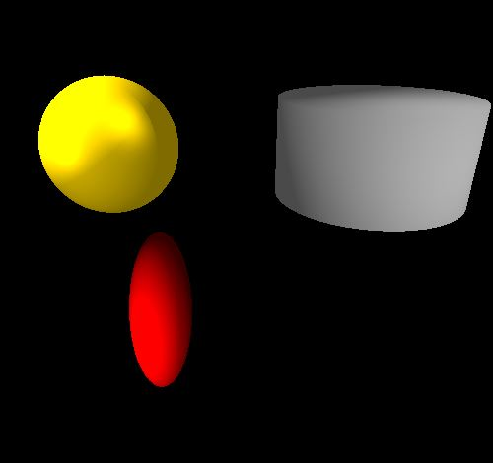

In the slides after analyzing the flat surface lighting based on the slides reducing the flat shading on slide 70 really helped reduce the texture of the sphere. Then going through the hierarchical steps between the different shapes of the nodes first initially using the same shaders for number 3 when importing the cylinder; it was easier to implement the ellipse since it was more related to the sphere. Once I have fully imported the sphere adding the colors was in part tricky based on where I utilized the sphere first the sphere and the ellipse were the same color so as I implemented the colors I separated the buffers so they could be independent which saved me from more pain in the lighting. After watching the video on YouTube how the shaders were implemented it gave me a guidance of what to do this was the most frustrating getting the multiple lights to work mainly for the sphere since it had most of the lights the intensity was too strong so I could not see the distinction, initially I thought it was the order of my variables in my draw function but all in all it was the numerical variables ambient, specular, and diffuse that I needed to change in my draw function.

Resources:

The slides

[http://lhh.tutor.com/?ProgramGUID=5740cad3-446b-4af2-94b3-be3d53860642#](http://lhh.tutor.com/?ProgramGUID=5740cad3-446b-4af2-94b3-be3d53860642)

https://www.youtube.com/watch?v=95WAAYsOifQ&t=189s